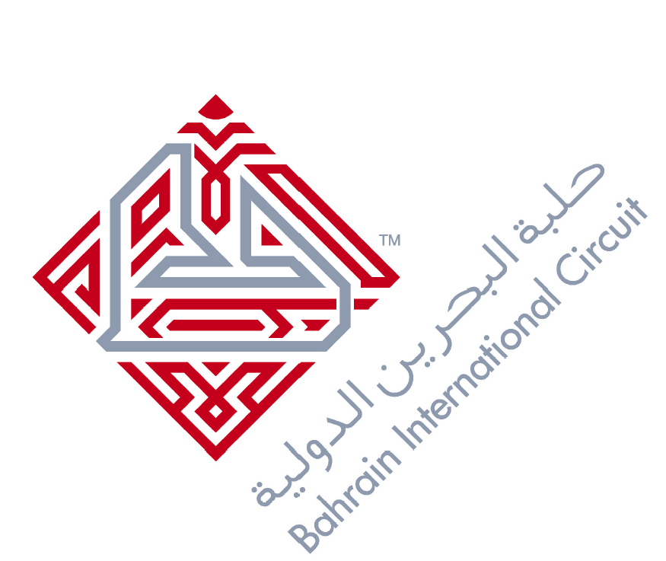
DEADLINE: Wednesday 23rd March 2016
Passport Information
Media Outlet: ( )
Passport No. | Nationality | D.O.B.  (Day/Month/Year) | Gender | Country of Birth | Passport Expiry Date  (Day/Month/Year) | Family Name | Given Name | Father’s Full Name | Hotel

- All details should be typed.
- Please note for Indian & Pakistani nationals, we require the father’s name column to be completed or a copy of the passport is required.
- For any Arab passport holders, we require a copy of their passport.
- Family & Given Names: All in Capital please.
- Copy of equipment list should be emailed with the form in order to process the customs clearance.
- Please E-mail back to: Media@bic.com.bh

